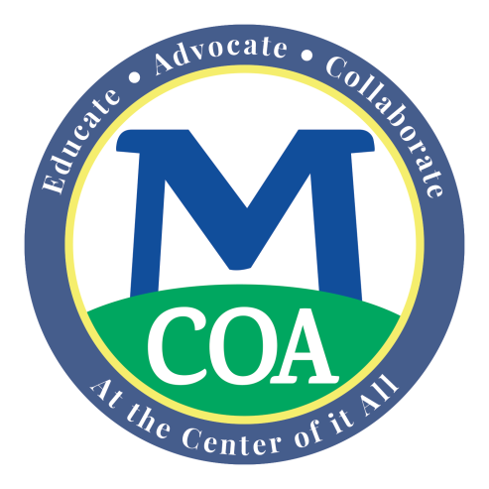
The MA “Circuit Breaker” Income Tax Credit
For Homeowners
and Renters
Age 65 and Older

YOU MAY GET A CASH REFUND ON YOUR STATE INCOME TAXES

The Massachusetts “Circuit Breaker” tax credit program is a program for adults age 65 + whose property taxes and half of the water and sewer bills are more than 10% of their annual gross income (or for renters, if their rent is greater than 25% of their income) and who meet a few other rules. You can receive this income tax credit even if you owe no state income taxes! Also, you can get this refundable tax credit if you also receive a local property tax exemption from your town’s Tax Assessor.

The value of the refundable credit can be as high as $1,080 for 2017 tax filers.
To obtain the credit, you must file a MA Income Tax “Form 1” and the “Schedule CB Form” for the 2017 tax year. You may file to get a refundable credit for the last 3 years* tax returns, if you have not yet done so. In addition to this year’s credit, the maximum credit you may receive for the past 3 tax years is: $10170 in 2016; $1,070 in 2015; and $1,050 in 2014.

You must meet the following guidelines to qualify for this refundable tax credit:
1. Be 65 or older by the end of the 2017 tax year for which you are filing.
2. Have income below the maximum level: (including Social Security and other income not ordinarily taxed in Massachusetts)

Income for tax year 2014 2015 2016 2017

Single 56,000 57,000 $57,000 $57,000

Head of household 70,000 71,000 $71,000 $72,000

Married, filing jointly 84,000 85,000 $86,000 $86,000

Married, filing separately, not eligible

3. The property that you own or rent must be residential property in Massachusetts that is your primary residence. (Note: Renters of public housing or who have a subsidized rental agreement are not eligible.)

4. The assessed valuation of your home cannot be greater than $747,000 for the 2017 tax year. Maximum home values for prior tax years are: 2014 - $691,000; 2015 - $693,000; and $720,000 for 2016. (There are no other assets limits for defining who may be eligible to get the tax credit.)

5. 10% rule for Owners: The credit will equal the amount your property tax bill (plus 50% of your water and sewer fees if not part of your property tax bill) exceeds 10% of your income, up to the maximum credit of $1,080 in 2017. It is okay if you also receive a local property tax exemption for seniors or earn a senior tax work off reduction. This credit will be applied to your reduced property tax bill amount.

6. 25% Rule for Renters: The credit will equal the amount by which 25% of your rental payments exceed 10% of your income, up to the maximum credit of $1,080 in 2017. The law assumes that 25% of rent goes toward property taxes.

7. Even if you don’t normally file an income tax return with the state, if you meet the above criteria you are most likely due a “refund” check/tax credit from the MA Department of Revenue. If you have an accountant, ask him/her for help with the previous 3 years.

8. The deadline for filing retroactive or amended tax returns (going back 3+ years) is April 15, 2018. For more information and to get the proper forms, call the Mass. Department of Revenue Customer Service at (617) 887-6367 for information and/or tax forms for this year and the past three years.

For help filing a tax return or amended returns for prior years, call your local Council on Aging at ______________________________ for information about where to meet with a volunteer tax aide. Or, hire an accountant to file your state income taxes for all the years you may be eligible.

To download the income tax credit tax forms -- Form 1 and the Schedule CB Form - go to the official Department of Revenue site at: https://www.mass.gov/lists/2017-massachusetts-personal-income-tax-forms-and-instructions . Or ask Council on Aging staff to print the forms for you.

