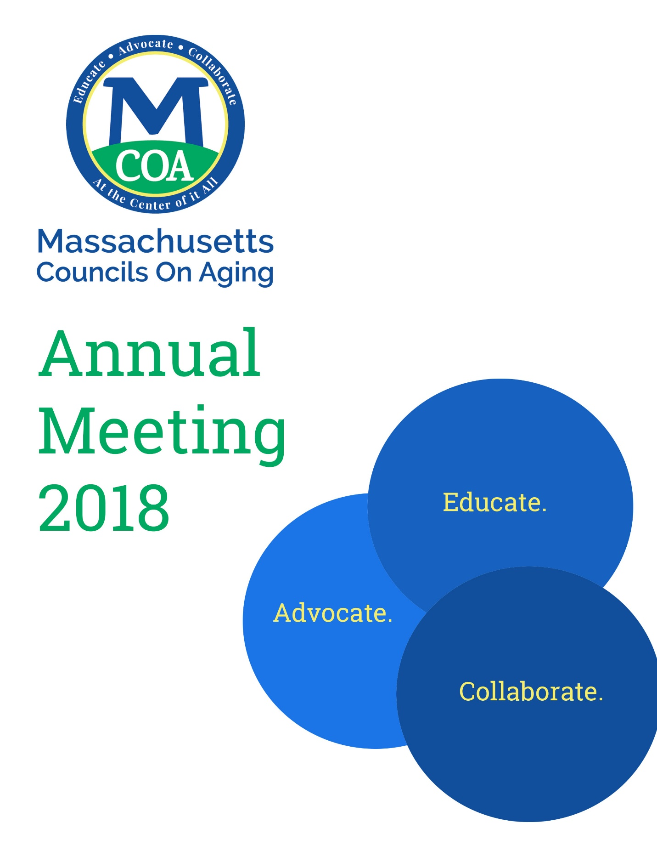

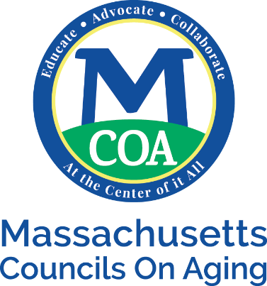
May 17, 2018

A Farewell Message from our President
As we gather for our 39th annual meeting, I wanted to thank the membership for allowing me to serve as your President over the last two years. In addition, I also want to thank my fellow Board and the staff of MCOA for their teamwork as we celebrate all that we have accomplished.
Our Association has grown:
- This year, following a concerted effort in resource development, we have received $1.8 million in grants and we provided over 100 subgrants back out to Massachusetts municipalities,
- Focusing on capacity building on the local level, we are providing hundreds of hours of technical assistance and have vastly expanded our resource and training portfolios,
- Finally this year we established our Behavioral Health unit creating elder mental health outreach teams and bringing dementia services into our communities.
Membership dues, collected from 97% of municipalities, was our primary source of income less than 10 years ago; now they are less than 15% on our budget. Our annual income is now five times larger than what it was five years ago and since then our staff has tripled.
As we expanded into Behavioral Health, MCOA embarked upon several new initiatives including the development of a comprehensive membership survey, active support for intergenerational programing and Grandparents Raising Grandchildren. We helped to create and funded bereavement and caregiver support groups. We retooled the Staff Certification process, developed a manual for local COAs to market their services and programs, and underwent an extensive rebranding campaign which included a refreshed logo and redesigned website. We strengthened our Regional Representative network. We funded falls prevention exercise programs; distributed adaptive devices for the hearing impaired and explored expanding regional technology centers for the visually impaired. Focusing on elder economic security MCOA promoted job fairs and other resources for older workers. We participated in a campaign to increase SNAP enrollment and other benefits and developed a manual with regional training focusing on housing. In addition, we participated in the statewide campaign to designate Massachusetts as the second Age Friendly State in the country. We were also designated the lead agency with Dementia Friendly Massachusetts and I was ask to represent MCOA on the Governor’s Council to Address Aging.
Our fall conference was the largest ever and we were joined by the CEO of NCOA, the President of ASA, and three New England State Association Presidents as well as the ACL Regional Commissioner, the Secretary of Elder Affairs, the Commissioner of DTA and for the first time in over a decade the Governor of Massachusetts, Charlie Baker.
During, the last two years we have advanced legislation that revises our Commonwealth’s property tax relief for seniors, expands the Good Samaritan Law, specified community training of professionals dealing with Alzheimer’s patients and with members of the LGBT aging community. Other legislative efforts focus on caregivers and credit reporting; providing adequate funding for Elder Affairs line items as well as supplemental funding for the salaries of front line workers. But our most successful achievement, will be the increase the formula grant from $8/elder to $12 a year ahead of schedule.
As I transition into the role of “Past President” I am willing to take it upon my responsibility to make sure this expansion is fully integrated into our Association and assist incoming President Rebecca Moriarty however needed.
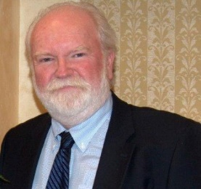
But before I step down, I want to recognize two retiring members of the Board of Directors. Vickie Lowe, our past legislative chair and current treasurer; and Barbara Farnsworth also our past legislative chair and past president who are both retiring this year. We wish them well.
Sincerely,
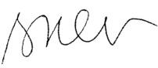
Brian O’Grady
MCOA President, & Director, Williamstown COA
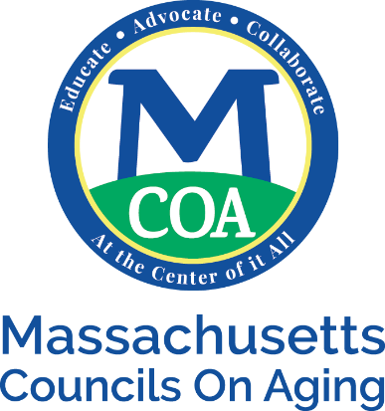

MCOA Awards:

Director of the Year Award: Pam Woodbury, Spencer COA
Advocates of the Year: Judy O’Connor, Millbury COA
Ruth Moy, Chinese Golden Age Club
Carolyn Villers, Mass. Senior Action Council
Innovator of the Year Award: Cindy Hickey, Somerville COA
Jeff McCue, SNAP Outreach, Department of Transitional Assistance
Life Time Achievement Awards: Barbara Farnsworth, Hingham COA
Lillian Glickman, UMass Boston
Director Recertification: Annmary Connor
Jayne Colino
Lauren Arms Ledwith Award: Donna Popkin and Massachusetts Association of Councils on Aging

NISC Programs of Excellence
Winner: Fundraising – Rockport COA-Lucky Duck Race
Honorable Mention: Community Development –Southborough-Southborough Trailblazers
Technology – Lexington Senior Services – Virtual Programming
Marketing – Amesbury COA – Greenleaf Supportive Day Marketing
Campaign

MCOA 2018 Index Report
Fall Conference Registrants : 370
COA’s represented at the Fall Conference : 166
Workshops held at the Fall Conference : 83
Vendors at the Fall Conference : 79
New Vendors at the Fall Conference : 30
New Sponsors at the Fall Conference : 2

Towns and Cities benefited from MCOA trainings, conferences, contracts, meetings : 68%
Individuals received CEU’s : 45
Technical Assistance Calls : 173
Number of Contracts written : 89

Towns and cities actively pursuing and Age-Friendly
community designations of May 2018 : 30
Towns and cities engaged in becoming Dementia Friendly : 100
Communities who are emerging Age-Friendly communities as of May 2018 : 68
Attendees at DFM Meetings in 5 regions with first round : 149
MA has more memory cafes than any other state at : 75

EMHOT contracts : 5
Towns and cities offered EMHOT services : 44
Hours of counseling provided to older adults in FY 2017
through EMHOT : 3500
Older adults in the Commonwealth who received
mental health services through EMHOT in FY 2017 : 190
Older adults served by EMHOT whose primary
diagnosis was Post Traumatic Stress Disorder : 21.65%
Older adults served by EMHOT who were at risk of suicide in FY 2017 : 10%
Older adults served by EMHOT that were referred by community
first responder or town department : 40%

FY 2018 fiscal budget : $2.2 million
Dues collected from members : 97%
Percentage of budget used for programs : 82%
Legislative visits made by David Stevens : 90

COA’s enrolled in DTA/SNAP /COA Community Partners October start : 14
Additional COA’s enrolled in DTA/SNAP/COA community partners April start

