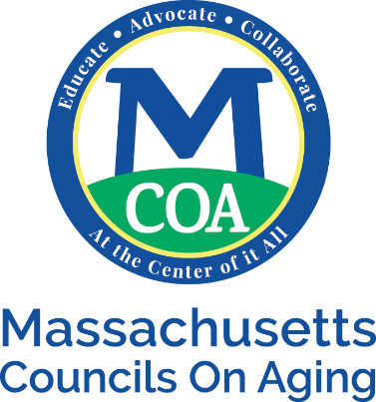

MCOA FY20 Dues Proposal

PROPOSED: The Board of the Massachusetts Councils on Aging recommends increasing MCOA Dues rate from $0.20/elder to $0.24/elder and thereby stay with the 2% level for FY20 (with minimums and
maximums outlined below). The chart below details this recommendation.

# Adults Age 60 and above Based on the US 2010 Census | Existing FY18 Rate@  $10/elder Formula Grant | Proposed FY20 Rate@  $12/elder Formula Grant
0-500 | $190 | $230
501-1100 | $220 | $265
1101-12,000 | $0.20/elder | $0.24/elder
12,001-15,000 maximum | $2500 | $3000
15,001-20,000 maximum | $3100 | $3750
20,001-30,000 maximum | $3425 | $4250
30,000+ maximum rate | $4500 | $6000
*Minim u m Formula Grant allocation rose from $5000 FY16 to $6000 FYl7.

EXAMPLE: The 'median' Massachusetts town with a population of 18,654 has approximately 3628 older adults (age 60+). MCOA's advocacy effort increased its local Formula Grant funding from $36,280($10/elder) to $43,536($12/elder) an increase of $7256.00. MCOA dues request for this median town went from $725.60 in FY l 7 to a proposed FY18 rate of $870.72 an increase of $$145.12 (2%).

BACKGROUND: The Formula Grant increase is part of our five-year campaign to raise the Formula from
$8 to $12/elder by 2020. We achieved our goal – ONE YEAR EARLY! An increase in the Formula rate triggers consideration of a MCOA Dues increase.

NEXT STEPS: This recommendation is slated to come before MCOA’s Board of Directors on August 29, 2018. If approved the proposal is sent to the full membership with a vote scheduled on December 6, 2018. If approved the new rate goes into effect July 1, 2019.

NOTE: If any town/city COA decides to not join MCOA, fees for any training, meeting or fee based event, will be charged at the higher rate.

