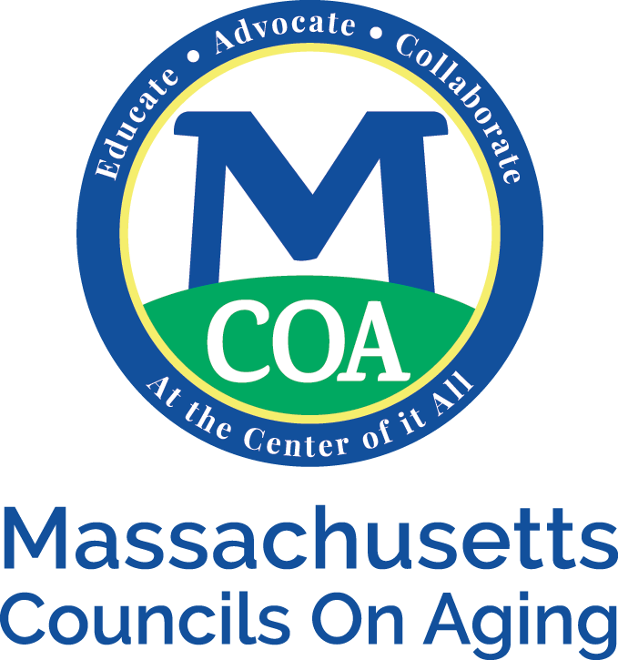
Employment Posting Policy

MCOA will post jobs and opportunities on our website free of charge to all members and partner agencies. The job postings will go out in the weekly briefs once. The postings will be kept on the website for thirty days. If a member or partner agency would like to keep it up, they will need to resubmit the posting.

MCOA will post their own job postings also in the weekly briefs and will be available on the website. MCOA will also look to post with partner agencies. For a senior staff position, a listing will also be with a for-profit employment agency.

