Living Wage Policy

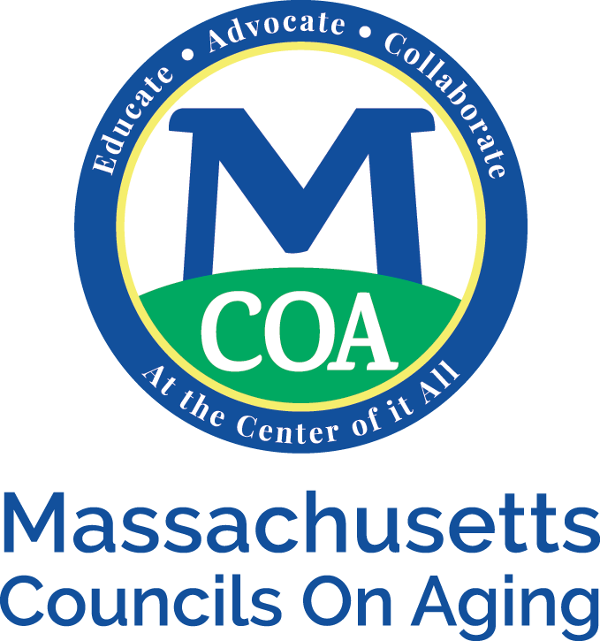
Employers are obligated to pay the state or federal mandated minimum wage, whichever is higher. MCOA has adopted the policy to pay at least the living wage as stated in Massachusetts.

