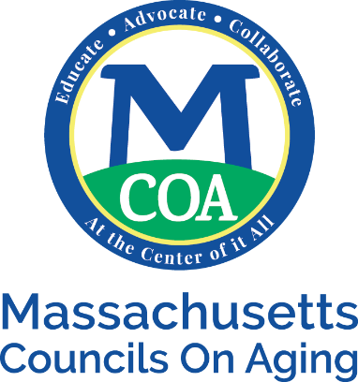

MCOA Meeting Fee Schedule

Protective, Government & Welcoming Place, Outreach | $20
Housing, Snap, Safety | $20; $30 non-members
Annual Meeting | $30
Membership meeting | $30
Small & Rural Conference | $30 for first member, $15 each member after
Fall Conference | Determined annually

