Travel Policy

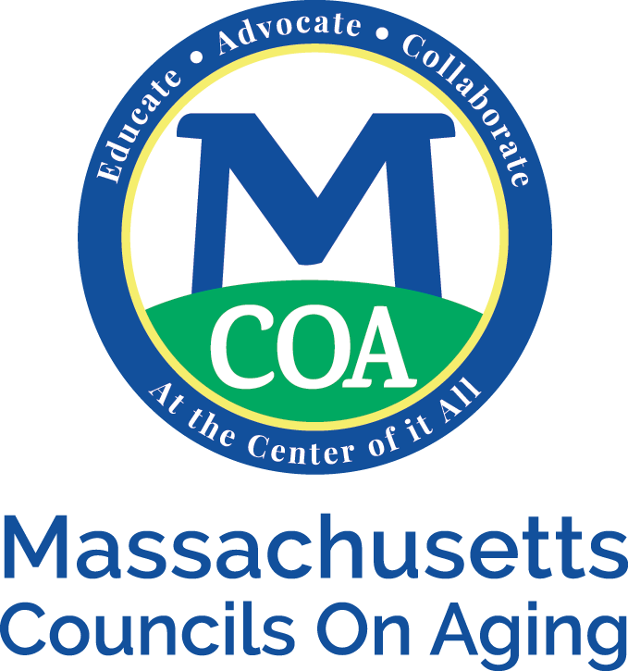
MCOA reimburses employees for mileage that is due to work related traveling. MCOA pays the standard rate set by the IRS in the beginning of each year. Tolls and parking will also be reimburse. Gas, repairs and insurance are not reimburseable. Any tickets, such as speeding or parking, during the time you are covering MCOA business, will not be covered.
If there is out of state traveling, MCOA will cover your mode of travel after it has been approved by the Executive Director.
To be reimbursed for mileage, a mileage report needs to be filled out and submitted monthly. Receipts for tolls and parking, needs to be submitted with the mileage report. If a receipt can not be obtained, such as for meters, it must be noted as such.
If an hourly employee needs to travel for MCOA business, the time to travel is considered work time and should be included on their timesheet.

