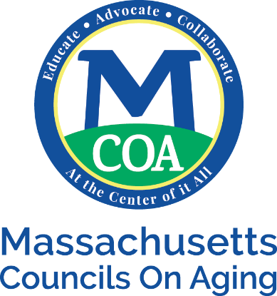

Weather Policy

EMPLOYEES: In the case of inclement weather, the decision about closing will be determined by the schools and/or the Councils on Aging. If the schools or the Councils on Aging is closed in your town or the town you work in, you are not required to come in. For employees that work from home, will be able to do so.

MEMBERS: In case of inclement weather, we try to make the determination to cancel or postpone a meeting 24 hours in advance and contact you through email and possibly phone calls. We also post a message on our website and on our telephone answering machine – 413.527.6425. If you have registered and paid for a meeting, the amount paid will be applied to the next meeting attended.

