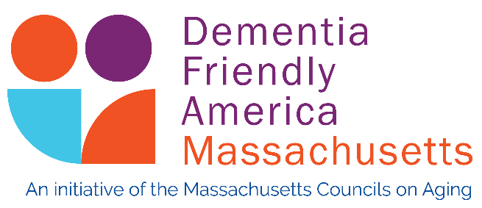

Want to be Recognized as a Community Making Progress Towards Becoming Dementia-Friendly?

As part of the 2018 grant from the Tufts Health Plan Foundation, Dementia Friendly Massachusetts is now recognizing communities across the Commonwealth that have pledged to continue their work to become more dementia-friendly. We applaud this ongoing effort to make people living with dementia and those who care about them feel welcomed and supported.

A copy of the pledge document is attached. It explains what actions a community need to take:

• Consult with the Dementia Friendly Massachusetts Project Manager
• Create an Action Team and identified a Team Leader
• Engage three or more community sectors in training
• Create an Action Plan that includes the involvement of persons living with dementia
• Utilize data from Community Profile from the Massachusetts Healthy Aging Data Report in our continued efforts

Communities are asked to collect signatures, including elected officials, and submit a PDF of the document to Patty Sullivan, Dementia-Friendly Massachusetts Program Manager at Patty@mcoaonline.com. Recognition certificates will be distributed at upcoming MCOA meetings.

Contact Patty Sullivan – Patty@mcoaonline.com – for your consultation or if you have questions.

As members of (community name)’s Dementia Friendly Action Team, we pledge to continue to engage in these efforts by taking action to improve our community and system capabilities, thereby optimizing the health, well-being and involvement of people with dementia and their care partners. We agree that every part of our community plays a role and that together, we can work to take steps to create a dementia friendly culture and facilitate the adoption of dementia friendly practices in all parts of (community name).

Whereas we;
❧Have consulted with the Dementia Friendly Massachusetts Project Manager
❧Have created an Action Team and identified a Team Leader
❧Have engaged three or more community sectors
❧Created an Action Plan that includes involvement of persons living with dementia
❧Will utilize data from Community Profile from the Massachusetts Healthy Aging Data Report in our continued efforts

We now hereby sign this pledge as a sign of our commitment to continue in our efforts to make and sustain (community name), as a Dementia Friendly Community.
Dated this (date) day of (month), (year)
Name & Affiliation Signature
____________________________________ _______________________________________
____________________________________ _______________________________________
____________________________________ _______________________________________
____________________________________ _______________________________________
____________________________________ _______________________________________
____________________________________ _______________________________________
____________________________________ _______________________________________

Who Should Sign? Action Team Members, engaged municipal and elected individuals, and the Age-Friendly Lead if your community is designated or in the process of being designated an Age-Friendly Community. You have the option of including signatures of engaged Sector Members.

