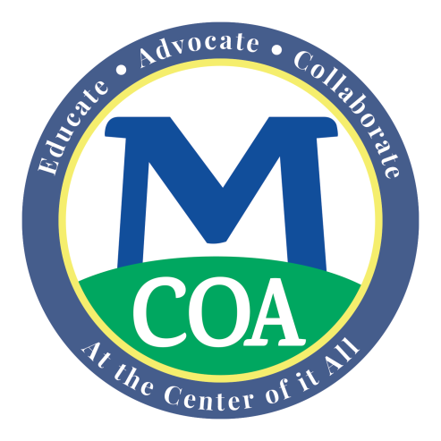
FACT SHEET
The MA “Circuit Breaker” Income Tax Credit
For Homeowners
and Renters
Age 65 and Older

Fact

YOU MAY GET A CASH REFUND ON YOUR STATE INCOME TAXES

- The Massachusetts “Circuit Breaker” tax credit program is a program for adults age 65 + whose property taxes and one-half of their water and sewer bill is more than 10% of their annual gross income
- Or, for renters, if the rent is greater than 25% of their monthly income and who meet a few other rules.
- Adults can get this income tax credit even if they owe no income taxes.
- Also, you can get this refundable tax credit if you also receive a property tax exemption from their town assessor or work in your town’s senior property tax work off program.
- The maximum value of the refundable credit will be $1,100 for 2018 tax filers.

To obtain the credit, you must file a MA Income Tax “Form 1” and the “CB Form” for the 2018 tax year. Also, if you’ve never filed for it before, you may be able to get a refundable credit for the last 3 years* tax returns.

You must meet the following guidelines to qualify for this refundable tax credit:
1. Be age 65 or older by December 31 of the tax year for which you are filing.
2. Have Income Below the Maximum Level: (including Social Security and any income not ordinarily taxed in Massachusetts)
Income for tax year 2018

Single $ 58,000

Head of household $ 73,000

Married, filing jointly $ 88,000

(Married, filing separately, not eligible)

3. The property that you own or rent must be residential property in Massachusetts that is your primary residence. (Renters of public housing or sites with subsidized rental agreements are not eligible for the tax credit.)

4. The assessed valuation of your home cannot be greater than $778,000 for tax year 2018. There are no other assets limits for defining who may be eligible to get the tax credit.

How Much Might You Get?
10% rule for Owners: For home owners, the credit will equal the amount your property tax bill (plus 50% of your water and sewer fees if not part of your property tax bill) exceeds 10% of your income, up to the maximum credit of $1,100.

25% Rule for Renters: The credit will equal the amount by which 25% of your rental payments exceed 10% of your income, up to the maximum credit of $1,100 in 2018. The law assumes that 25% of rent goes toward property taxes.

Again, it is okay if you also receive a local property tax exemption for seniors or earn a senior tax work off reduction. This credit will be applied to your reduced property tax bill amount.

Even if you don’t normally file a state tax return, if you meet the above criteria you are most likely due a “refund” check (tax credit) from the Dept. of Revenue. If you have an accountant, ask him/her for help with this year and /or previous years. For more information and to get the proper forms, call the Mass. Department of Revenue Customer Service at (617) 887-6367 for information and/or tax forms for this year and the past three years.

For help filing a tax return or amended returns for prior years, call your local Council on Aging. They may have a volunteer tax aide. Or, hire an accountant to file your state income taxes for all the years you may be eligible. To download the tax forms -- Form 1 and the CB Form - go to the official Department of Revenue site at: https://www.mass.gov/how-to/apply-for-the-circuit-breaker-credit.

