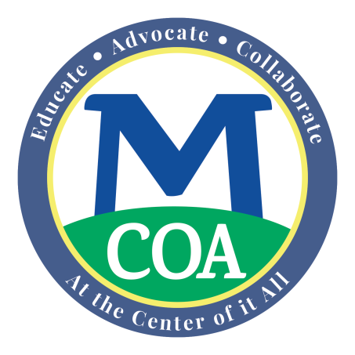

Property Tax Exemptions for Adults Age 65 and Older

- An exemption relieves a taxpayer from the legal obligation to pay the full amount of their local property tax.
- In most cases, a homeowner does not repay an exemption.
- Exemption programs typically provide between $500 and $1,000 per year in property tax relief to the adult who meets the town’s specific income and asset requirements
Who is eligible for an exemption and the amount of the relief depends upon the local options enacted within each city and town. State law gives cities and towns a “local option” to decide which local tax relief programs it will offer its residents and to set local guidelines for who will qualify.) For example, municipalities may choose to give property tax exemptions to certain individuals, including older adults age 65+ or 70+, veterans and their surviving spouses, blind persons, surviving spouses of firefighters or policy officers, and those facing special hardship due to infirmity, poverty or active military status, and others. For the exact eligibility requirements of your city or town, especially due dates for applying, check with the Tax Assessor in your city or town.
To get an exemption, the homeowner must file an application each year with the town Assessor where the property is located. Generally, applications for exemptions are due on December 15th each year or 3 months after the actual tax bills are mailed, whichever is later. Check with the local Assessor to know the actual filing deadline. Filing on time is required. By law, the Assessors may not waive this filing deadline, nor act on a late application, for any reason. Also, filing an application does not entitle the homeowner to delay paying their tax payment.
You must satisfy eligibility rules relating to age, domicile, ownership, occupancy, annual income and assets. A few pointers:
- You must meet all eligibility requirements as of July 1 of the tax year. (The fiscal year of cities and towns begins July 1 and ends the following June 30.) If you do not meet all requirements as of July 1, you cannot receive all or any portion of the exemption for that tax year.
- You must own and occupy the property as your “domicile”. Your domicile is where your principal and legal home is located, your family, social, civic and economic life is centered and you plan to return whenever you are away. You may have more than one residence, but only one domicile.
- Each city and town decides what the maximum income level can be in order to be eligible – it can range widely. Ask your local Assessor for the actual income levels used for their exemptions.
- Likewise, each city and town decides upon an amount of savings and other resources (but usually not including your primary residence) you may have and still be eligible – this too can vary widely. Ask your local Assessor for the actual resource limits levels they permit.
- You must provide the Assessor with whatever information is reasonably required to verify your eligibility. This information may include, but is not limited to:
  - Birth certificates.
  - Evidence of ownership and occupancy.
  - Income tax returns, bank and other asset account statements.
- If you own the property with someone who is not your spouse (for example, your children, sibling or other adults) then each of the other co-owners must also satisfy the annual income and asset tests.
- With limited exceptions, you may only receive one exemption under Mass General Law for each fiscal year. If you qualify for more than one, the Assessor will assign the one that provides the greatest benefit to you.

Finally, you may receive an exemption and then choose to defer all or a part of the balance of the (reduced) property taxes for that same year. Discuss this with the Assessor as well.

The local Assessor is located at: Insert Office Address.
You may call the Assessor’s office at: Insert phone number and hours.

This fact sheet is not designed to address all questions or issues. To find out about the specific eligibility and application requirements in your city or town, you must contact your local Board of Assessors. Under state law, only your Board of Assessors, as the local tax administrator, can decide whether you qualify for an exemption. If you disagree with its decision, you may appeal.

Source: MA Department of Revenue, Division of Local Services, fact sheet on property tax exemptions at: http://www.mass.gov/dor/docs/dls/publ/brochures/elderly.pdf .

(As of November 2017)

