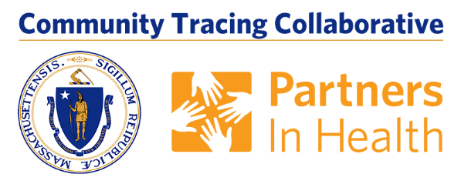
Answer The Call And Help Stop The Spread Of COVID-19

The MA COVID Team and local boards of health are working together on a contact tracing program to help reduce the spread of COVID-19 in Massachusetts.

Contact tracing is an important tool, and the MA COVID Team is part of the Community Tracing Collaborative created by Governor Charlie Baker. Everyone who has tested positive will get a call from their local board of health or the MA COVID Team, making sure they have the support they need, and to find out who they have recently been in contact with. The MA COVID Team or the local board of health will then talk to those contacts, encouraging them to get tested and to stay at home to avoid spreading the virus further.

Together with massive testing and hospital care follow up, contact tracing is absolutely essential to stop the virus and get our communities moving again.
What Happens Next? Answer the Call, Stop the Virus!
- You will receive a phone call from the MA COVID TEAM. The area codes
will either be: 833 or 857. It is important to ANSWER THE CALL. Answering the call helps everyone in our communities – someone else may be depending on your important input!
- How can I verify MA COVID Team is calling? MA COVID Team uses the area code 833 or 857 and your phone will say the call is from “MA COVID Team.” Calls will be made daily from 8 a.m. to 8 p.m. The MA COVID Team will not ask for social security information or health insurance information.
- During the phone call a Case Investigator will ask you for a list of all the people and places you were within 6 feet of during the 48 hours prior to your symptoms. For those who do not have symptoms, include all contacts 48 hours prior to your diagnosis. The Case Investigator will also ask for the phone numbers of any people you identify so that they can be reached and notified about their exposure.
- While we encourage you to inform your contacts about your illness, the state will not share your information. The MA COVID Team will call your contacts and tell them they have been exposed to COVID-19 so they can get tested but will not release your name. This process is called contact tracing, and it is a very important part of fighting this pandemic and stopping transmission.
- The state will not share any information with immigration officials or ICE.
- If you are staying at home during the isolation period, the Case Investigator will also discuss any needs you may have for this time and may connect you with a Care Resource Coordinator who will help you get the support you need.
- A Case Investigator and/or your local board of health will check in on you regularly to monitor your symptoms and needs.
USEFUL RESOURCES:
- To learn more about contact tracing visit mass.gov/matracingteam
- Check your symptoms online
- For non-emergency questions and help: Call 2-1-1 or live chat

