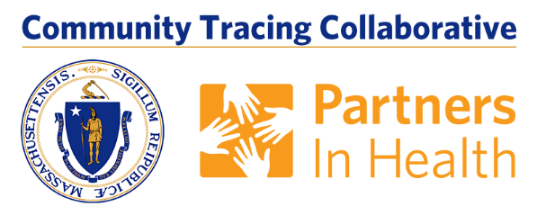

The Executive Office of Elder Affairs (EOEA) has curated a small toolkit of material from The Contact Tracing collaborative, including a brief social media-ready message, a video and images you can use to help spread the word about the importance of contact tracing. For additional materials and messaging, please see the complete package from Partners in Health at: [https://indd.adobe.com/view/ddf0df22-e52f-49ad-b145-4f09218dd297]

Social Media-Ready Message:
Answer the call and stop the spread of COVID-19! Verify the MA COVID Team is calling, look for calls with area code 833 or 857 & your phone will say the call is from “MA COVID Team”. Help stop the spread of the virus. Learn more at mass.gov/matracingteam

[include image or video]

Video:
The MA COVID Team is Calling

For other languages and video download - https://drive.google.com/drive/folders/18HnKjnVkSqaE9HJHjQ4nudZOU7X4z6ll

Banner:
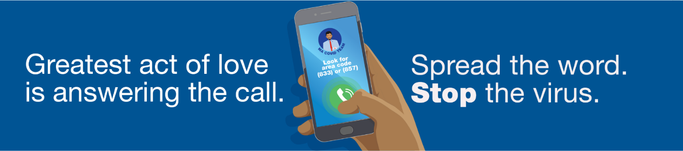

Graphic 1:
For other languages - https://drive.google.com/open?id=1bx0Xf4vveVDPpEcTHrAug7UTnZIu7qRj
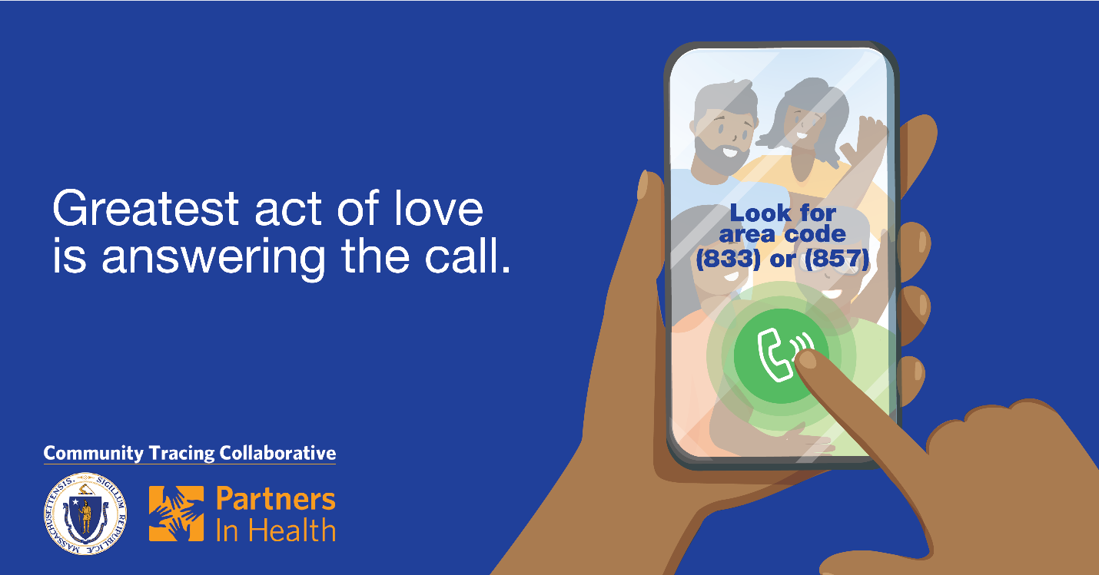

Graphic 2:
For other languages - https://drive.google.com/open?id=1bx0Xf4vveVDPpEcTHrAug7UTnZIu7qRj
