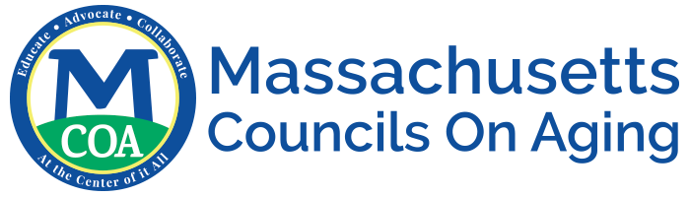

Community Scan

- Resources in your Community
  - Food
    - IIIC meals
    - Meal delivery kits
    - In-home chef
    - Mobile markets
    - Food rescue programs
    - Independent bag/box programs
    - Grocery stores, corner markets
    - Farm Stands/Farmers Markets/Mobile Markets/CSA
    - Food pantries, dining sites
    - Brown Bag programs
    - Family Food Box
    - Commodity Supplemental Food Program
    - COVID-19 resources
    - Vendors with new business models (farms delivering, SNAP curbside pay)

  - Transportation
    - COA transportation
    - ASAP volunteers
    - Ride share (Uber, Lyft, Safr, etc.)
    - Instacart, Peapod, etc.
    - Telegrocers

  - Benefits
    - SNAP/HIP (Supplemental Nutrition Assistance Program/Healthy Incentive Program)
      - COA/DTA Partnerships
      - Supplemental benefits, P-EBT
      - Average award
    - Senior Nutrition Farmer’s Market Program (coupons, homebound produce)

