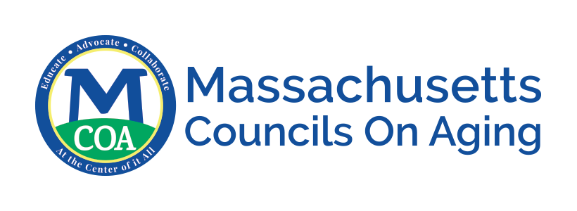

COVID-19 Operations Plan
Transportation

Per State guidance, all businesses in the state of MA must develop a written control plan outlining how its workplace will comply with the mandatory safety standards for operation in the COVID-19 reopening period. This template may be filled out to meet that requirement. Control plans do not need to be submitted for approval but must be kept on premise and made available in the case of an inspection or outbreak.

Work with your BOH and local leaders to learn what safety standards are required for Transportation. Resources include:

Massachusetts Executive Office of Human Services Transportation guidance
CDC guidelines for non-emergency transportation
Community Transportation Association of America guidelines and resources
For MA grants and funding information for COA transportation, visit this site.

Council on Aging Information
COA Name:
Address:
Contact name:
Contact phone and email:
Number of employees on-site:

Social Distancing
- Ensure that all persons, including employees, customers, and vendors remain at least six feet apart to the greatest extent possible. Examples of guidance include:
- Create 6 ft distancing instructions.
- For 4-5 passenger vehicles, the driver should be in the front and no more than one passenger in the back.
- For 7-9 passenger vehicles, the driver should be in the front and no more than two passengers in the back, with each passenger exercising physical distance.
- For vans carrying more than nine passengers, no more than four passengers in a vehicle, exercising physical distance between one another.
- Install plexiglass if needed or driver compartment barriers.

- Establish protocols to ensure that employees can practice adequate social distancing. Examples of guidance include:
- All non-essential transportation should be limited.
- Consider postponing use of volunteer drivers and/or finding alternative means of transportation if social distancing cannot be maintained during transport and appropriate cleaning cannot be performed.
- Create a schedule to ensure all participants have rides to programs.

- Post signage for safe social distancing

- Require face coverings for all drivers and riders

- Implement additional procedures. Please describe them here:

Hygiene Protocols
- Provide hand washing capabilities. Examples of guidance include:
- Provide access to handwashing inside center, if applicable.
- Provide hand sanitizer to passengers and driver.

- Ensure frequent hand washing by employees and provide adequate supplies to do so. Examples of guidance include:
- Purchase hand sanitizer and/or mounted sanitizer stations inside vehicles.
- Provide gloves and masks for drivers.

- Provide regular sanitization of the high touch areas of vehicles.
- Follow guidelines for how to clean hard surfaces (such as door handles, seat belt buckles, etc.) and soft or porous surfaces (such as fabric seats, etc.). Use products that are EPA-approved for use against the virus that causes COVID-19external icon and that are suitable for porous surfaces.

- Implement additional procedures, (please describe below): Examples of additional procedures include:
- When using a vehicle with a lift or if direct contact is needed, PPE should be worn, including a mask and gloves. Change PPE after assisting each individual.
- Placing signage of no eating or drinking on the vehicle.
- Placing signage to cover coughs and sneezes.

Staffing & Operations
- Provide training for Transportation staff regarding the social distancing and hygiene protocols. Examples of guidance include:
- Avoid touching your eyes, nose and mouth.
- Wash hands frequently with warm water and soap.
- Stay at least six feet apart from others while in social settings.
- Physical contact should be avoided unless being assisted by the driver. This includes, hugging, shaking hands, etc.
- Wear a cloth face covering or mask at all times.
- If you are not wearing your mask for any reason, cover your coughs and sneezes with a tissue, then dispose of the tissue in the trash and immediately wash your hands.
- Anyone who does not follow protocol may be denied services.
- Provide training to staff if someone refuses to follow protocol.
- Make sure all above protocol is communicated with staff prior to returning to the facility.
- Check with your local BOH for reporting procedures if anyone sick uses your transportation services.

- Ensure employees who are displaying COVID-19-like symptoms do not report to work
  - If employees become ill with respiratory symptoms while at work, they should be sent home as soon as possible.

- Establish a plan for employees getting ill from COVID-19 at work, and a return-to-work plan. Examples of guidance include:
  - Anyone who develops symptoms while on the job/at the facility should keep their mask/face covering on, notify their supervisor or upper management, and leave the facility.
  - Those with symptoms of respiratory illness should stay home. After recovering from illness, employees should only return to work consistent with the guidelines established by your local BOH.

- Implement additional procedures, (please describe below): Examples of additional procedures include:
- If screening is required for use of transportation services, you may want to use the same screening document or template employed by your local first responders (fire, police or emergency services).
  - Determine with your BOH whether screening of transportation staff and riders will be conducted
- Contact drivers about returning to work.
- Provide drivers and riders with established guidelines for using transportation services.

Cleaning & Disinfecting
- Establish and maintain specific cleaning protocols. Examples of guidance include:
- Every day each vehicle will also undergo two rounds of complete interior disinfection and cleaning. The first to use CDC-approved wet products and the second industrial UVC disinfection to reach corners, cracks and hard-to-reach surfaces.
- If a single vehicle is to be used by different drivers on the same day, the drivers’ area will be carefully disinfected between those drivers’ shifts.
- Disinfect vehicles often, including radio and communications equipment and all surfaces touched by drivers.
- Follow guidelines for how to clean hard surfaces (such as door handles, seat belt buckles, etc.) and soft or porous surfaces (such as fabric seats, etc.). Use products that are EPA-approved for use against the virus that causes COVID-19 and suitable for porous surfaces.

- Ensure that when an active employee is diagnosed with COVID-19, cleaning and disinfecting is performed. Examples of guidance include:
- Follow guidelines for how to clean hard surfaces (such as door handles, seat belt buckles, etc.) and soft or porous surfaces (such as fabric seats, etc.). Use products that are EPA-approved for use against the virus that causes COVID-19 and suitable for porous surfaces.

- Implement additional procedures. Please describe below:
- Check with your local BOH for disinfecting procedures if anyone sick has used your transportation services.

