1) TIC - Talking Information Center in Marshfield MA where volunteers read publications all day long - - [TICnetwork.org](https://linkprotect.cudasvc.com/url?a=http%3a%2f%2fTICnetwork.org&c=E,1,0RTuwIXeB5sNRY3xfptr-vM_N3_x28kHd6yjk8n_kQsp2Io1JldDsbYvzYVvXcGReupo614UlA8kqTDXtXDfsI65l6Jz5wdYpexMoiSVxRqIHlK-Yg,,&typo=1)  (They also have a monthly low vision support group that is attended by seniors from many towns: Duxbury, Hingham, Scituate, Marshfield - in fact - any senior, located anywhere is welcome to attend - they have great topics and great guest speakers from the Mass Commission for the Blind, etc.....

2) MassMatch - Easter Seals Assistive Technology "Loan" Program - Boston & Worcester - [https://www.massmatch.org/inventory/](https://linkprotect.cudasvc.com/url?a=https%3a%2f%2fwww.massmatch.org%2finventory%2f&c=E,1,K6B7Cltv7O0US90UlC0KjmceOprQDnrePc2vELpCaEoAVzrmZzGuDkO6tEiwbx14l0PJXymccrdsGeMImtTmSQiZC1a9L-XmaCPjohF945NcbkH4IMM,&typo=1)

3) My Senior Center software now offers a Simple Conference Line (conference calling services that is a dedicated / unique phone # for your senior center) (we use it for our bingo w 25 people calling-in)

 -*" My Senior Center software has launched a super simple conference line that provides a unique number for each Center and doesn't require participants to dial a code or password. Just dial the number assigned to your Senior Center and conduct your event with all your people attending. If you'd like more information on MySeniorCenter's conference calling service, contact them at:****866.739.9745   or***[***annmarie@myseniorcenter.com***](mailto:annmarie@myseniorcenter.com)*or*[***www.myseniorcenter.com***](https://linkprotect.cudasvc.com/url?a=http%3a%2f%2fwww.myseniorcenter.com&c=E,1,wtKBmn5GyJIQ4cAMUXORG7AEL_-DQhXvgF-QDdpaurAAZjvb4Y4omDMlGIqNDWOFbbsxKmA5jmXdBasKuwturhVL2W7joGb_jeRDTJ_SUxT6gd8vbWdAKEq49trT&typo=1)

**Spiritual Book Club suggestions**

The Laws of Spirit by Dan Millman

The Alchemist by Pablo Coelho

The Four Agreements by Don Miguel Ruiz

A New Earth by Eckhart Tolle

The Things I Know for Sure by Oprah Winfrey

**Pictures of Grab and Go Make your own Meals**

**Provides a Meal**

**Gives Senior an activity**

1. Picture of a make your own pizza grab and go
2. Picture of a cup with a package of cocoa and cookies

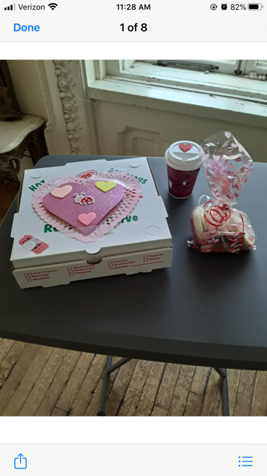

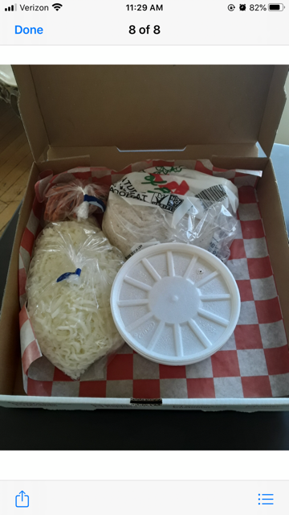

Sample of Post Cards sent to seniors

