The Commonwealth of Massachusetts
Executive Office of Elder Affairs

One Ashburton Place, 5th Floor

Boston, Massachusetts 02108

CHARLES D. BAKER
Governor

Tel: (617) 727-7750
Fax: (617) 727-9368
www.mass.gov/elders

KARYN E. POLITO
Lieutenant Governor
ELIZABETH C. CHEN, PhD, MBA, MPH
Secretary

Commission on Malnutrition Prevention among older adults

Year THREE Annual Report - December 2020

MGL. PART 1. TITLE 2. Chapter 19A Section 42:
There shall be with the department a commission on malnutrition prevention among older adults. The commission shall consist of the secretary of elder affairs or a designee, who shall serve as chair, the commissioner of public health or a designee, the commissioner of transitional assistance or a designee, the commissioner of agricultural resources or a designee, the senate and house chairs of the joint committee on elder affairs or their designees and 9 persons to be appointed by the governor, 1 of whom shall be a physician, 1 of whom shall be a university researcher, 1 of whom shall be a community-based registered dietitian or nutritionist working with an Older Americans Act-funded program, 1 of whom shall be a representative of a hospital or integrated health system, 2 of whom shall be nurses working in home care, 1 of whom shall be a registered dietitian or nutritionist working with a long-term care or assisted living facility, 1 of whom shall be a registered dietitian or nutritionist representing the Massachusetts Dietetic Association and 1 of whom shall be a representative from the Massachusetts Association of Councils on Aging, Inc.
The commission shall make an investigation and comprehensive study of the effects of malnutrition on older adults and of the most effective strategies for reducing it. The commission shall monitor the effects that malnutrition has on health care costs and outcomes, quality indicators and quality of life measures on older adults. The commission shall: (i) consider strategies to improve data collection and analysis to identify malnutrition risk, health care cost data and protective factors for older adults; (ii) assess the risk and measure the incidence of malnutrition occurring in various settings across the continuum of care and the impact of care transitions; (iii) identify evidence-based strategies that raise public awareness of older adult malnutrition including, but not limited to, educational materials, social marketing, statewide campaigns and public health events; (iv) identify evidence-based strategies, including community nutrition programs, used to reduce the rate of malnutrition among older adults and reduce the rate of re-hospitalizations and health care acquired infections related to malnutrition; (v) consider strategies to maximize the dissemination of proven, effective malnutrition prevention interventions, including community nutrition programs, medical nutrition therapy and oral nutrition supplements, and identify barriers to those interventions; and (vi) examine the components and key elements of clauses (i) to (v), inclusive, consider their applicability and develop strategies for pilot testing, implementation and evaluation.
The commission shall file a report annually on its activities and on any findings and recommendations to the house and senate chairs of the joint committee on elder affairs and chairs of the senate and house committees on ways and means not later than December 31.

Membership
2020 MPC Members
Representing | Current Appointee
Secretary of Elders Affairs, Designee (Chair) | Carole Malone Co-Chair  Shirley Chao Co-Chair  Amy Sheeley Secretary
Commissioner of Public Health, (Designee) | Diana M. Hoek
Commissioner of Transitional Assistance (Designee) | Penny McGuire
Commissioner of Agricultural Resources (Designee) | Rebecca Davidson
Member of the House of Representatives (Designee) | Representative Elizabeth Poirier
Member of the House of Representatives (Designee) | Representative Danielle Gregoire
Member of the Senate (Designee 1) | Mary Giannetti
Member of the Senate (Designee 2) | Linnea L. Hagberg
Physician | Dr. Sarah Phillips
University Researcher | Helen Rasmussen
Community-based registered Dietitian or Nutritionist Working With Program Funded by Older Americans Act | Margery Gann
Rep. of a Hospital of Integrated Health System | Kris M. Mogensen
Nurse Working In Home Care 1 | Milaina Mainieri
Nurse Working In Home Care 2 | Myclette Theodule
Registered Dietitian or Nutritionist Working with Long-Term Care | Dalia Cohen
Registered Dietitian or Nutritionist Representing MA Dietetic Association | Tara Hammes
Rep. from MA Association of Councils on Aging, Inc. | Pamela Hunt, Tara Hammes

In 2020, the Malnutrition Prevention Commission (MPC) adapted to meet challenges accompanied by the COVID-19 pandemic. The work of the MPC is especially important because seniors, who are at the highest risk for this novel disease, have faced unpresented issues related to food security, isolation, transportation, and fear of infection to name a few. All of these issues raise the already high risk of malnutrition in this population. EOEA and other commission affiliated agencies participated in the cross-agency Food Security Task Force, which was convened by the Massachusetts COVID-19 Command Center in response to increased demands for food assistance across the Commonwealth. EOEA is grateful to all of the commission members and statewide Older American Act (OAA) nutrition programs for their time, tireless energy, dedication and commitment during this crisis. The MPC originally scheduled meeting on March 10th was held remotely on August 11th.

2020 ACCOMPLISHMENTS

I. Do a COVID Check Campaign (April, 2020)

- Together with Defeatmalnutrition.today, EOEA and commission members promoted the #DoaCOVIDcheck campaign which include information and memes for the public to ensure older adults were not in need of food and other resources during the pandemic. This was distributed through 36 organizations and individuals via their websites and a variety of social media channels (Facebook, Twitter and LinkedIn). There were more than 12,000 followers on these postings. Some examples below.
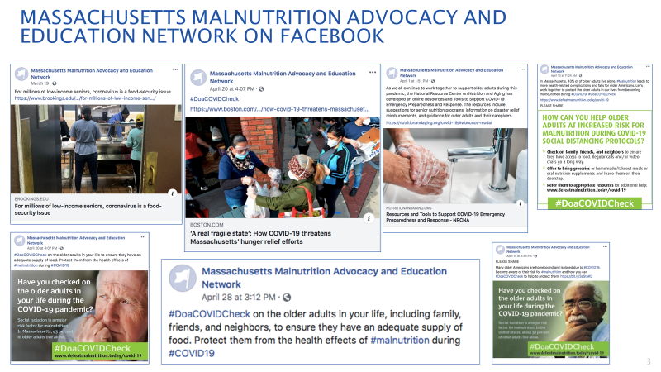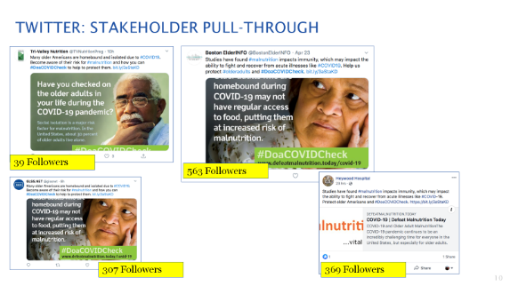
II. Be a Nutrition Neighbor Campaign
- Memes and infographics
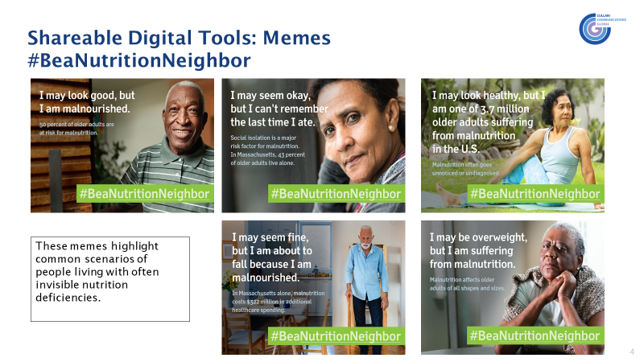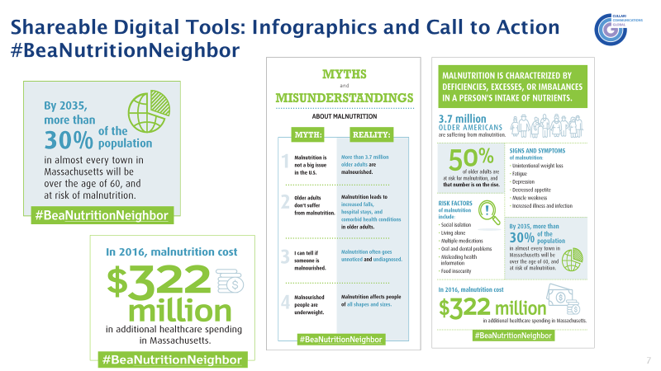
- The campaign had 32 engaged groups who posted the campaign message over 100 times, resulting in close to 110k impressions.
- The Malnutrition awareness message was delivered to more than 100,000 people in MA during Malnutrition Awareness Week, October 3-9, 2020.
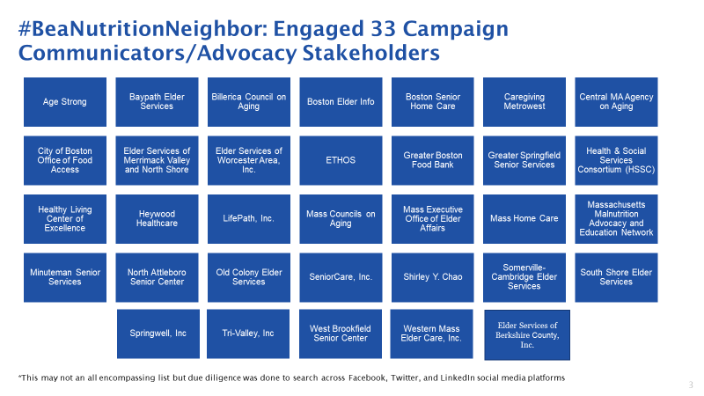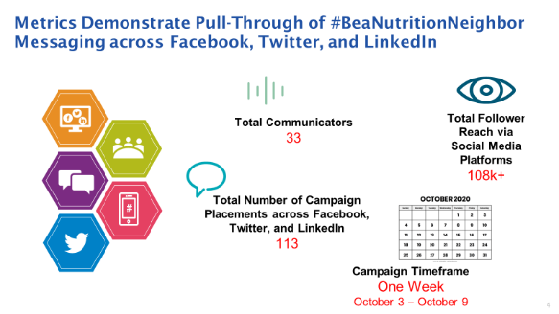
- #BeaNutritionNeighbor spotlight will be featured in first “Malnutrition Connection” edition in 2021.

(2020 Recommendation: MPC will launch “Adopt a Neighbor” –A nutritional health awareness campaign to raise awareness statewide.)

III. Malnutrition Awareness Weeks

- Promoted malnutrition awareness during Older Americans month in May.
- Member agencies participated in Aspen’s Malnutrition Awareness WeekTM October 5th-9th events and acted as ambassadors
- OAA nutrition programs delivered malnutrition information on menu backs, at “grab and go” sites and used remote technology and social media
IV. Presentations: (alphabetical orders)

- Shirley Chao and Helen Rasmussen gave a presentation on integrating frailty and malnutrition screening into community care titled "Strategies to Engage Older Adults and Their Caregivers" at the Academy of Nutrition and Dietetics Food & Nutrition Conference & Expo Virtual Event FNCE session “Are You Prepared for the Decade of Healthy Aging 2020-2030?” (10/19/2020). The other two presenters were Heather Keller (Canada) and Clare Corish (Ireland).
- Tara Hammes (MCOA) presented ‘Malnutrition: Five Tools you Can Use’ at the September MCOA Membership Meeting
- Tara Hammes (MCOA) presented ‘Nutrition Programs in and Around COAs’ plenary session at MCOA’s Fall Conference in October. This included a recorded an interview with Robert Blancato of National Association of Nutrition and Aging Service Programs and Defeat Malnutrition Today
- Tara Hammes (MCOA) presented ‘Food as Medicine’ at the November MCOA Membership Meeting
- Tara Hemmes (MCOA) conducted nutrition webinar ‘Motivating Healthy Habits’ for the National Center for Equitable Care for Elders in December
- Tara Hemmes (MCOA)co-presented on the implementation of the updated National Blueprint: Achieving Quality Malnutrition Care for Older Adults.
- MCOA’s Statewide Nutrition Forum – created and presented this virtual training which provided an overview of the impact of malnutrition, how COA’s can start a community nutrition program, completed a community checklist exercise, learned of food and nutrition resources as well as the opportunity to become a SNAP partner with DTA/UMass. Tara Hammes presented MCOA’s nutrition initiatives during the August MCOA Statewide Outreach Meeting. Provided an overview of the work in progress and resources available to outreach workers.
- Kris Mogensen (BWH) gave a presentation as part of ASPEN’S Malnutrition Awareness WeekTM programming, “Learning from COVID-19: the Value of Nutrition Across the Care Spectrum” on October 7, 2020. This was an international session in conjunction with the Canadian Nutrition Society and the British Association for Parenteral and Enteral Nutrition.
- Kris Mogensen (BWH) gave a presentation to the Massachusetts Dietetics in Health Care Communities Dietetic Practice Group on “Nutrition Challenges in the Aging Bariatric Patient”
- Amy Sheeley and Leigh Hartwell (Merrimac Nutrition) presented a session titled “Healthy Nutrition in a Pandemic: Eating for a Strong Immune System and Innovative Education Methods to Reach Seniors” at the Massachusetts Councils on Aging Association annual meeting (10/19/2020).

V. Publications/Activities:

- The MA Department of Agriculture included malnutrition education in its “MA Senior Farmers’ Market Nutrition Program” magazine which is published in three languages (English, Spanish and Chinese).
- MA Councils on Aging (MCOA) published the Commission’s 2019 annual report.
https://mcoaonline.com/advocacy/malnutrition/
- Boston’s Age Strong Commission ( formerly known as the Commission on Affairs of the Elderly) published malnutrition awareness information in its Seniority Magazine. https://www.boston.gov/sites/default/files/file/document_files/2019/06/june_2019_web.pdf
- MA Department of Transitional Assistance (DTA) provided SNAP Nutrition Education (SNAP-Ed) in many senior centers throughout the Commonwealth. DTA have also added more information on physical activity for Seniors on our SNAP-Ed website https://www.mahealthyfoodsinasnap.org/
- MA Malnutrition Commission’s activities were featured in the national Defeat Malnutrition Today (DMT)’s monthly Newsletter – Malnutrition Connection. https://www.defeatmalnutrition.today/resources
- In September, EOEA published new malnutrition information on its website and link to all resource materials https://www.mass.gov/nutrition-program-for-seniors
- Kris M. Mogensen (BWH) had two publications related to malnutrition this year:
- Mechanick JI, Carbone S, Dickerson RN, Hernandez BJD, Hurt RT, Irving SY, McCarthy MS, Mogensen KM, Ochoa Gauthier JB, Patel JJ, Prewitt TE, Rosenthal M, Warren M, Winkler MF, McKeever L. Clinical nutrition research and the COVID-19 pandemic: a scoping review of the ASPEN COVID-19 Task Force on Nutrition Research. JPEN J Parenter Enteral Nutr. 2020 Oct 23. Online ahead of print
- Evans DC, Corkins MR, Malone A, Miller S, Mogensen KM, Guenter P, Jensen GL. The use of visceral proteins as nutrition markers: an ASPEN position paper. Nutr Clin Pract. 2020 Oct 30. Online ahead of print

(2019 Recommendation: Encourage all member agencies to publish and promote evidence-based malnutrition resources designed for older adults, care providers and professionals via websites, social media and printed materials such as newsletters).

The Commission had one meeting in 2020

The MPC met remotely on August 11, 2020

  - Presentation of “The COVID-19 Crisis in Long-Term Care” by Karl Pillemer PhD,
Department of Human Development, Professor of Gerontology in Medicine at Weill Cornell Medicine, Senior Associate Dean for Research and Outreach, College of Human Ecology Cornell University.

- LTC facilities tend to be highly conducive to the spread of COVID-19
- These facilities have accounted for a disproportionate number of COVID-19 cases, as well as COVID-19 deaths – more than 40% of deaths from the disease in the United States overall, while LTC facilities house only a small percentage of the population – and more than 80% of COVID-19 deaths in some states.
- Modeling LTC populations separately from community-living populations would help characterize outbreaks in each.
- When we can identify, assess, and develop prevention and safety plans for nursing homes and assisted living, COVID-19 illness and death rates will decline steeply.

  - Presentation of “Novel Implementation of a Multicomponent intervention for Brain Health in underrepresented Elders (NIMBLE)” by Kieran Reid, PhD MPH, Scientist / Assistant Professor USDA Human Nutrition Research Center on Aging Tufts University.

- Age-related cognitive decline has a profound impact on the daily functioning of older adults, their families and healthcare systems.
- Currently over 6 million US older adults are living with Alzheimer’s disease or a related dementia (ADRD). This number will double by 2030 and more than triple by 2050.
- The impact of social interaction and environmental stimulation due to the COVID-19 pandemic may be detrimental to brain aging.
- ADRD is complex and multifactorial. Targeting several risk factors and mechanisms simultaneously may be necessary to optimize preventative effects.
- The NIMBLE study seeks to:
  - Develop a remote /home based multicomponent intervention to reach underserved older adults at risk for cognitive decline
  - Initially try to reach African American/Black and Latinx older adults in Greater Boston
  - In Phase I, the overarching objective will be to develop, test and refine NIMBLE to demonstrate its initial feasibility.
  - In Phase II, the overarching objective is to examine the effects of NIMBLE on cognitive performance and known ADRD lifestyle-related risk factors and identify “at-risk” older adults.
  - The intervention includes meal kit delivery, homebased physical activity, cognitive training, social engagement, and metabolic and vascular risk reduction as well as telehealth coaching from Tufts staff. Participants are given an iPad and a 4 month cellular plan.
  - The project period is October 2020-September 2025.

  - Presentation of “Be a Good Nutrition Neighbor” Nutritional Health Awareness Campaign by Tiffany Nagle
- #DoaCOVIDCheck: Q2 2020 Campaign Engagement & Recap
- Q4 2020 Proposed Social Media Awareness Campaign: #BeaNutritionNeighbor:
  - Employ similar grassroots “surround sound” activation that again recognizes elder nutrition as a serious issue in Massachusetts
  - Bring together internal and external stakeholders engaged in the Massachusetts Malnutrition Commission and their contacts.
  - Customize a social media toolkit for dissemination during the end of September and into Malnutrition Awareness Week (October 3-9, 2020)
- Key campaign messages to address during COVID
  - Older adults are a vulnerable population who are already at risk for poor nutrition (malnutrition) because of increased risk from chronic disease and food insecurity.
  - Social isolation resulting from social distancing will compound the risk for malnutrition.
  - Malnutrition impacts immunity and the ability to fight and recover from infections and acute illnesses, which makes nutrition more important than ever during the current crisis.
  - "Be a Nutrition Neighbor" underscores the needs of the population we are trying to advocate for (43.1 percent live alone, 36.5 percent live in rural areas--making COVID-appropriate neighborly check-ins even more important
- Tiffany reviewed #BeaNutritionNeighbor shareable DRAFT Digital Tools including memes, infographics and Facebook frames.
- Next steps include creating an “Agreement on a Call to Action” and identification of a landing page for state resources similar to DMT’s #DoaCOVIDCheck

  - Member report: COVID-19 impact
  - Carole Malone (EOEA): Mass Grown Farm Exchange platform was launched. It assists farmers, fishers, food buyers, and ag-related businesses to connect, exchange, and find products and services. Also, the EOEA nutrition program team has been participating in the cross-agency Food Security Task Force. Through the work of the task force, a Food Assistance Decision Tree was recently launched to help residents in need determine which programs they might be eligible for. The Food Assistance Decision Tree tool can be accessed at mass.gov/findfoodhelp.
  - Shirley Chao (EOEA): Food security is the most important issue. Home meal delivery increased 50% to 40,000 meals daily, congregate meal programs shifted to grab and go offerings (averaging 2000 daily), and programs stood up mobile markets with “Senior on the Go” buses providing transport. The Commonwealth used the federal government’s Family First Coronavirus Respond Act (FFCRA) funds to distribute 7 days of frozen or shelf stable meals to 85,000 seniors and participated in the US Department of Agriculture Farmers to Families food box program, completing two rounds of deliveries to over 34,000 seniors in need in the community by September.
  - Amy Sheeley (EOEA): Materials including slide presentations and menu backs related to nutrition and food safety during the pandemic were distributed to the local nutrition programs. Programs are implementing remote nutrition education to seniors.
  - Pam Hunt (N. Atteboro COA) COAs have many increases in number of participants receiving home-delivered meals and many started grab-and-go meals due to congregate meal sites being closed. Many COAs are providing a weekly bag of groceries and/or pantry items and have had 2-4 federal food box distributions. Food insecurity is being addressed throughout the Commonwealth.
  - Margery Gann (ETHOS): Program saw approximately 50% increase in home delivered meals. Agency received a large Boston Resiliency grant allowing the program to provide meals to those under 60.
  - Kris Mogensen (BWH): Many floors of the hospital were converted to ICUs to handle the influx of COVID patients with many of the most critical begin over 65 years of age.
  - Diana Hoek (DPH): The WIC Nutrition Program is providing remote services until at least Sept. 30th., There was a rapid influx of applications in April which leveled out during the summer. Program caseload increased by about eight percent
  - Linnea Hagberg (SeniorCare): Program has weekly calls with COAs, providing contactless deliveries.
  - Dalia Cohen: Home delivered meals increased drastically. Wellness checks have been critical, provided by phone when necessary. “Grab and go” participation at meal sites has increased. There has been higher than usual demand for Farmer’s Market Program coupons.
  - Pam Hunt (MCOA) and Tara Hammes (MCOA): MCOA has been hosting regional calls to share information. The website has a COVID-19 information section as well as nutrition updates and a nutrition advocacy page. 8 COA’s have become SNAP partners with another 15 to being in January.
  - Milaina Mainieri (Minuteman): Conducted assessments by telephone. Seniors have had increased need of homemaking support such as shopping and meal preparation. Also meals on wheels participation has increased resulting in the need for more drivers.
  - Helen Rasmussen (HNRCA, Tufts University), as moderator, collaborated with Dr. Shirley Chao who presented “Are You Prepared for the Decade of Healthy Aging 2020-2030?” at the Academy of Nutrition and Dietetics FNCE virtual conference 10/19/2020. Dr. Chao spoke on Integrating Frailty and Malnutrition Screening into Community Care: Strategies to Engage Older Adults and their Caregivers.
- Preparation for future events
  - ASPEN’s Malnutrition Awareness Week TM October 5-9, 2020
    - Kris Mogensen discussed the program which consists of educational CE webinars, on-demand videos, infographics and other resources on malnutrition. Topics for the 5 webinars include sarcopenia, malnutrition in the community and learning from COVID-19.
    - All members and partners were encouraged to become ambassadors.

Coming Year ACTIVITIES (2021)
- MPC members will continue to adapt to the needs facing older adults during the COVID-19 crisis and evaluate long-term impact. MPC will do a similar Malnutrition Awareness campaign with a specific call to action aligned to the goals of the Commission. MPC members will encourage healthcare stakeholders to conduct Awareness Campaigns at state legislative gatherings and community events.
- MPC will encourage member agencies to publish and promote evidence-based malnutrition information
- MPC will promote the 2020-2025 US Dietary Guidelines and continue to advocate the importance of raising awareness of malnutrition among older adults.
- MPC will join ASPEN to celebrate the passage of Senate Resolution 716, designating the week of October 5 through October 9, 2020, as “Malnutrition Awareness Week.” Not only does the resolution raise awareness of malnutrition, it recognizes ASPEN and healthcare professionals for their efforts in the treatment and prevention of malnutrition. Its passage underscores the importance of funding existing federal nutrition programs to combat malnutrition, and supports emergency funding for critical nutrition programs for the duration of the COVID-19 pandemic.
- MPC will distribute and present their report to key stakeholders including: Massachusetts Councils on Aging, ASAPS/Nutrition Programs, Health Policy Commission, Massachusetts Academy of Nutrition and Dietetics, and the Massachusetts Hospital Association.

Suggested next steps for member agencies include the following:

MA Executive Office of Elder Affairs (EOEA):
- EOEA will work with the Governor’s office to designate a week in May of 2021 for “Older Adult Nutrition Week”.
- EOEA will further promote and participate in national events such as ASPEN’s Malnutrition Awareness WeekTM in October 2021. Materials regarding malnutrition in older adults will be distributed to the entire senior network of consumers and providers.
- EOEA’s website will continue to publish and promote evidence-based malnutrition resources to enhance the likelihood information will reach seniors, healthcare providers and caregivers.
- EOEA will explore how best to facilitate collaboration between hospitals and the aging services network in MA regarding the value and role of home delivered meals in reducing hospital readmission.

Massachusetts Department of Public Health (DPH)
- DPH will help to coordinate “Older Adult Malnutrition Awareness Week” and participate in corresponding events.
- DPH will assist the MPC on both data collection and public awareness campaigns.
- DPH will work with the MPC to raise awareness about malnutrition in older adults throughout its bureaus, divisions and programs.
- DPH will disseminate the commission’s studies and findings to appropriate DPH programs to reduce barriers and health care costs as well as improve quality indicators and outcomes.
- DPH will participate in national events such as ASPEN’s Malnutrition Awareness WeekTM in October 2021.

Massachusetts Department of Transition Assistance (DTA):
- DTA is committed to providing low-income individuals food assistance and a path to economic long-term self- sufficiency.
- DTA will continue to partner with EOEA and a working group of advocates to focus on initiatives to help elders access and maximize SNAP benefits.
- DTA and MCOA’s ongoing collaboration has resulted in an additional 20 Councils on Aging becoming contracted SNAP Outreach Partners in 2020. A total of 39 Councils on Aging receive federal reimbursement for the work they do with assisting seniors enroll in SNAP.
- DTA’s Senior Assistance Office is a specialized unit which designed to meet the specific needs of the Commonwealth’s elder population. Included in this office is a dedicated phone line for elders that will directly connect them with a live case manager.
- DTA has recognized that SNAP benefits can help prevent malnutrition in older adults and therefore will commit to promote and attend the “Older Adult Malnutrition Awareness Week” events.
- DTA will include malnutrition information along with its Nutrition Education program (SNAP-Ed) on its website which highlights programming for elders.
- DTA will continue working on the SNAP senior medical deduction and Elderly Simplified Application Project (ESAP)

Massachusetts Department of Agriculture (MDAR):
- MDAR has identified opportunities to incorporate the Commission’s recommendations into existing programs and initiatives. MDAR will continue to collaborate with partner organizations to evaluate how to effectively integrate the recommendations into its programs.
- MDAR has committed to incorporating evidence-based malnutrition awareness information into The Senior Farmers’ Market Nutrition Program (SFMNP), nutrition education magazine. The program will also work with participating market managers to increase awareness of malnutrition and provide information on the resources needed to reduce it.
- MDAR will continue to collaborate with the Massachusetts Department of Transitional Assistance on the Healthy Incentives Program (HIP). The program provides a monthly reimbursement for SNAP recipients to purchase fruits and vegetables. Approximately 50% of the families who have earned HIP reimbursements have included seniors.

Aging Services Access Points Agencies (ASAPs) /OAA nutrition programs:
- ASAP/OAA nutrition programs will promote “Older Adult Malnutrition Awareness Week” and participate in corresponding events.
- ASAP/OAA nutrition programs will support dissemination of materials regarding malnutrition in older adults provided by EOEA.
- ASAP/OAA Nutrition programs will develop and institute internal processes to implement EOEA-mandated MST screening and follow-up.
- ASAP/OAA nutrition programs will establish protocols to address needs of individuals identified as experiencing or being at-risk for malnutrition.
- ASAP/OAA nutrition programs will encourage outreach to local healthcare providers to raise awareness of malnutrition risk and MST screening and availability of ASAP nutrition services to address malnutrition.
- ASAP case managers and intake workers will receive basic training in identifying overt physical manifestations of malnutrition.
- Home Care consumers who are certified as nursing-facility eligible (ECOP and waiver) will be offered an annual nutrition consultation.

Mass Association of Councils on Aging (MCOA)
- MCOA will continue to focus on food security and malnutrition in 2021to reach large number of older adults in the Commonwealth
- MCOA will participate in Older Adult Malnutrition Awareness Week and related events.
- MCOA will publish evidence-based malnutrition prevention research on the revised nutrition advocacy website page
- MCOA will provide training, technical assistance and educational opportunities for councils on aging and senior center staff to enhance their ability to provide malnutrition prevention information and effective programs to Massachusetts older adults
- MCOA will include malnutrition prevention in their yearly conference that provides training on topics relevant to councils on aging, senior centers and other providers working with older adults
- MCOA will continue to partner with/participate in task forces, work groups, coalitions and agencies to strengthen its malnutrition prevention work
- MCOA will continue to provide one-on-one assistance to council on aging directors and their staff to evaluate and enhance their nutrition initiatives
- MCOA will create and share additional nutrition tools to improve older adult nutrition
- MCOA will form an advisory committee to guide the trade association's nutrition activities

Massachusetts Academy of Dietitians and Nutritionists (MAND)
- MAND will share Food is Medicine information and related campaigns raising awareness of inadequate nutrition to families, caregivers, and peers of seniors
- MAND will encourage healthcare stakeholders to conduct appropriate malnutrition prevention campaigns at state legislative gatherings and community event
- MAND will highlight malnutrition through its Public Policy Workgroup, action alerts and the MA Day on the Hill event for dietetic students
- MAND will contribute to the work of MPC by reaching its members throughout the Commonwealth. The malnutrition week and related events will be promoted via the blog and social media accounts
- MAND members will be offered a list of malnutrition resources and website links via the blog and at the Annual Nutrition Convention & Exposition (ANCE)
- MAND will highlight evidence-based malnutrition research and food insecurity resources

Jean Mayer USDA Human Nutrition Research Center on Aging (HNRCA) /Tufts University (Academic/Research organization)
- HNRCA will attend “Older Adult Malnutrition Awareness Week” and participate in corresponding events.
- HNRCA will work with other academic research organizations and MPC to make dietary policy recommendations, and offer trainings and education which will improve the nutrition status of older adults. These topics from their study results include immune function, vitamin and mineral absorption, physical capacity as well osteoporosis, cardiovascular disease, diabetes, cataracts and macular degeneration.
- HNRCA/ Tufts University will publish evidence-based malnutrition research as it comes available.
- HNRCA will also assist community organizations to conduct MNT outreach to treat malnutrition.
- HNRCA researcher Dr. Susan Roberts with support from Dr. Shirley Chao and Commission Member Dr. Helen Rasmussen will collaborate with MA EOEA, Boston Commission and Ethos in proposing a clinical research study that involves cognitive measurements, with an intervention involving a nutrition supplement bar rich in nutrients of interest for optimal brain function in older adults.

Brigham and Woman Hospital (BWH):
- Malnutrition has a negative impact in the acute care setting. BWH is exploring participating in the Malnutrition Quality Improvement Initiative, in accordance with the Academy of Nutrition and Dietetics. A number of studies conducted at BWH have demonstrated how this problem directly affects members of the Commonwealth.
- Use BWH Malnutrition QI initiative as a best practice and encourage other hospitals to participate.
- Request data collection on malnutrition screening from hospitals as a baseline and also analyze to see if there are any disparities among certain groups, location where efforts should be focused. Continued collection of prevalence data can show change over time.

The Greater Boston Food Bank (GBFB):
• GBFB will continue to promote malnutrition awareness campaigns on social media platforms.
• GBFB will promote “Older Malnutrition Awareness Week” on social media platforms and blogs.
• GBFB will participate in “Older Malnutrition Awareness Week” events.
• GBFB will work with DTA on activities to help close the “SNAP Gap” for seniors.

CLOSING
EOEA is grateful to the Legislature for its continued interest in the impact of malnutrition prevention research and education, and for creating the Commission on Malnutrition Prevention Among Older Adults to allow us to study methods to prevent and reduce malnutrition in the Commonwealth. With increased needs brought by the pandemic, continued growth in the elder population, and the high cost of health care, MPC will continue to serve an important function by working with the EOEA Secretary to help improve nutrition among elders and reduce rising health care costs

