Social Media Toolkit
MA Partnership for Food Safety Education
May 2023
Social Media Toolkit
Massachusetts Partnership for Food Safety Education
Stay Food-Safe This Season
Summer 2023: Cookout Season (May-June)

Introduction
The Massachusetts Partnership for Food Safety Education is a collaboration of state and federal agencies, organizations and associations working together to reduce foodborne illness by improving food safety knowledge and skills of Massachusetts consumers and food workers. Founded in 1998, the Partnership will be celebrating its 25th anniversary in 2023. Together the Partnership and our partners have developed numerous fact sheets, curricula, online training programs, videos, presentations, exhibits, multi-language materials and more to inform and education food workers and consumers about the importance of food safety in the home and workplace. Partnership members extend the efforts of other members through sharing materials and resources, developing uniform food safety messages, and implementing collaborative programs.
This edition is the second of the Partnership’s new educational effort, the “Stay Food-Safe This Season” Social Media Campaign. The CDC estimates that each year 48 million people will get sick from foodborne illness, resulting in 128,000 hospitalizations and 3000 deaths in the U.S. By educating food workers and consumers in ways to prepare and store foods safely, we can prevent the negative effects of foodborne disease. Timely topics to be addressed in summer include grilling foods safely with attention to cross-contamination issues, and time and temperature concerns for picnics and in hot weather situations. The early season campaign also lists an optional message in support of World Food Safety Day (June 7, 2023), using World Health Organization materials.
Our Stay Food-Safe campaign features seasonal messages that Partnership members can post on their Instagram, Facebook, Twitter, LinkedIn, and other sites to share timely information for consumers. Messages will include those developed by or adapted from USDA, FDA, and CDC, as well as those created by the Partnership to accompany messages in our online fact sheets. Through this program, we hope that Partners will reach consumers with important food safety information and resources, increase awareness of the materials available on the mafoodsafetyeducation.info website, and extend the educational efforts of our partners.
#mafoodsafetyeducation
www.mafoodsafetyeducation.info

Stay Food-Safe this Summer Campaign: Summer Cookouts (May/June)
Theme: Summer Cookouts, Message from the MA Partnership of Food Safety Education
Duration: 5/15/2023-5/26/2023 (pre-Memorial Day gatherings); plus 6/7/23 (World Food Safety Day)
Request:
- Post one or more of the following messages or graphics at least 2 times per week on your agency’s social media sites (Twitter, Facebook, Instagram or LinkedIn) during the Promotion month. Please post the slide with the Partnership logo and website, as well as hashtag #mafoodsafetyeducation.
- Send the toolkit or an adapted version to your network of organizations so that they can post messages on their own social media accounts, newsletters, etc.
- Please keep a record of where it was posted and reach (record form in toolkit). Submit your Evaluation by June 10 here: MPFSE Food Safety Summer Social Media Evaluation
Toolkit: Choose messages and graphics (copy GIFs from toolkit or links) below.
Messages (Twitter, Face Book, Instagram, LinkedIn, etc.) Use as is, or edit/add as desired.
Summer Food Safety Tips:
- Do You Wash Your Hands Correctly? Most people don’t. Wash hands with soap and warm water for 20 seconds before cooking and after handling raw meat and poultry.
Learn more at mafoodsafetyeducation.info #mafoodsafetyeducation

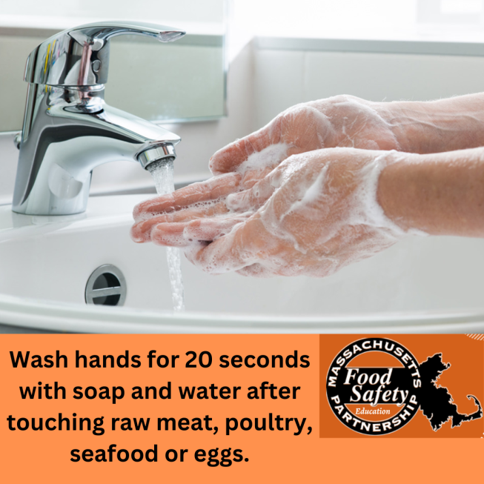
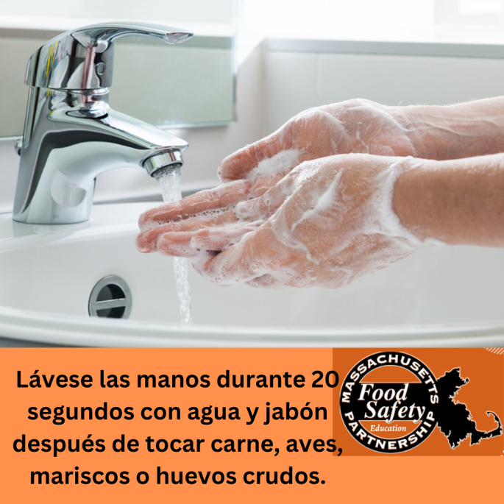
- Keep Germs Off Your Supper:
  - Use separate cutting boards, plates, and utensils to avoid cross-contamination between raw meat or poultry and foods that are ready to eat.

Learn more at mafoodsafetyeducation.info #mafoodsafetyeducation

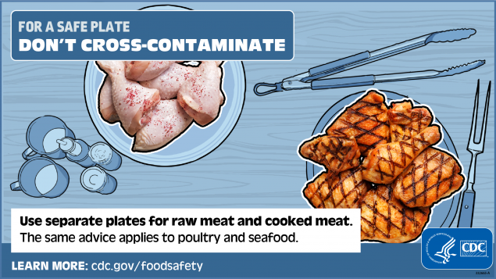
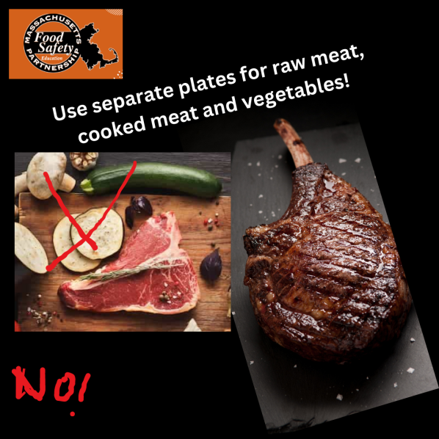

- You Can’t Tell By Looking:
  - Use a food thermometer to ensure your meat and poultry foods have reached a safe internal temperature.
  - Color is never a reliable indicator of safety and doneness. Always use a food thermometer when grilling outside.

  - Meat and poultry cooked on a grill tend to brown quickly on the outside but may not be fully cooked on the inside. Use a food thermometer to check the temperature.

  - NEVER partially grill meat or poultry and finish cooking later.

Learn more at mafoodsafetyeducation.info #mafoodsafetyeducation

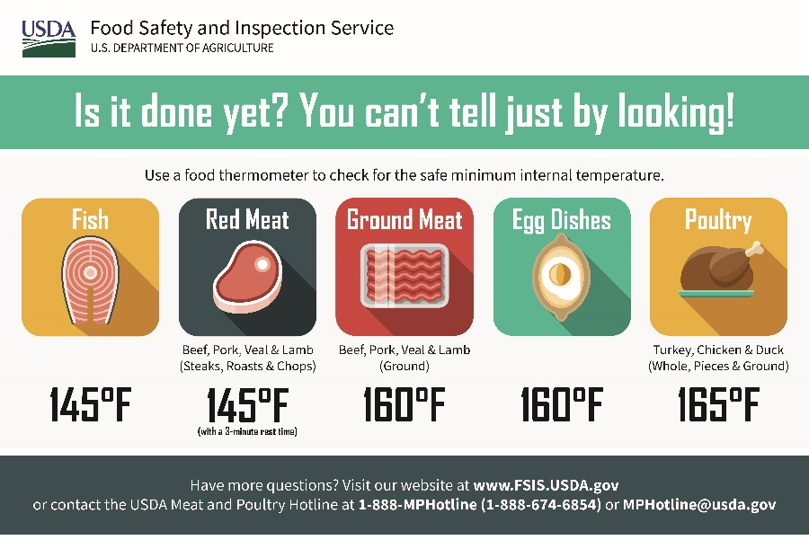

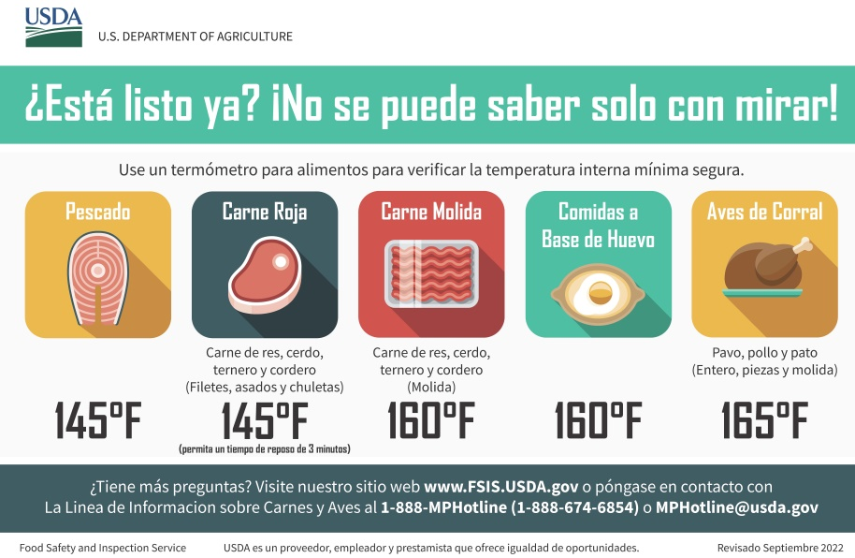
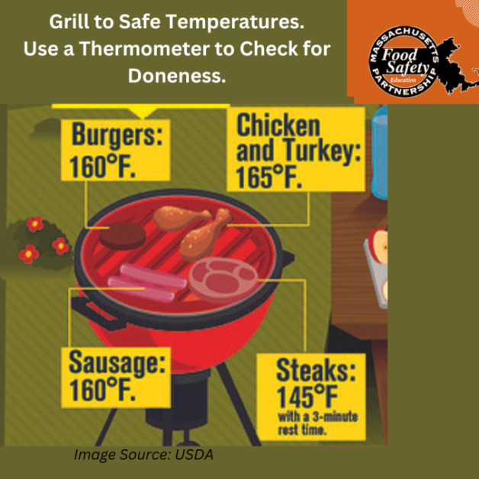
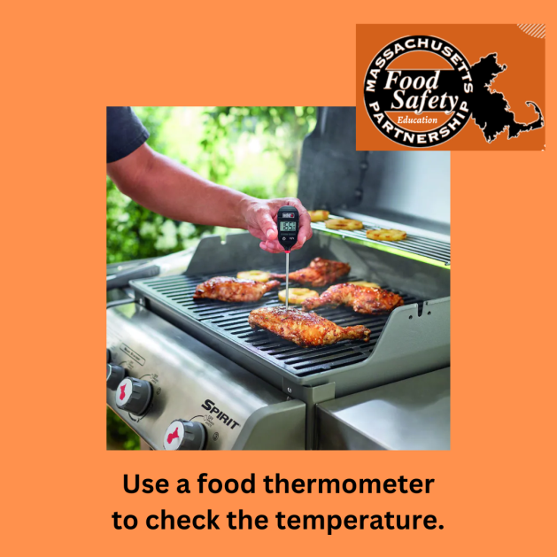
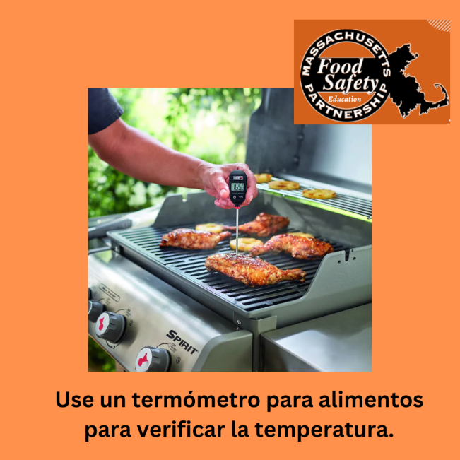

- Cook Your Food to a Safe Internal Temperature
    - Cook beef, pork, and lamb steaks to 145 F.
    - Cook fish to 145 F
    - Cook ground beef, pork, and sausages to 160 F
    - Cook chicken and turkey to 165 F
Learn more at mafoodsafetyeducation.info #mafoodsafetyeducation

- Keep Food Cold When It’s Hot Out:
  - Chill foods promptly if not consuming immediately after cooking. Do not leave food out for longer than two hours, or one hour on hot days over 90 degrees.
  - Use a cooler with ice to hold cold foods for picnics or on road trips.
Learn more at mafoodsafetyeducation.info #mafoodsafetyeducation

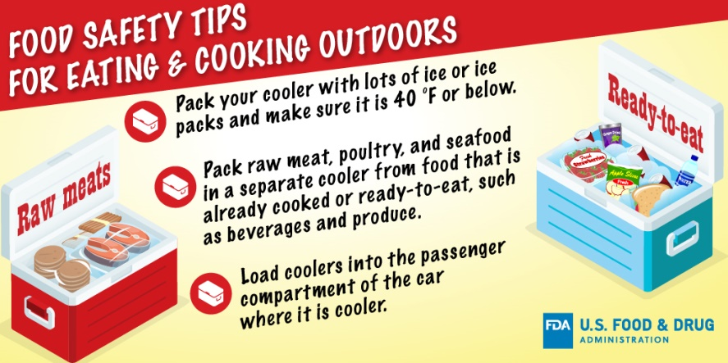
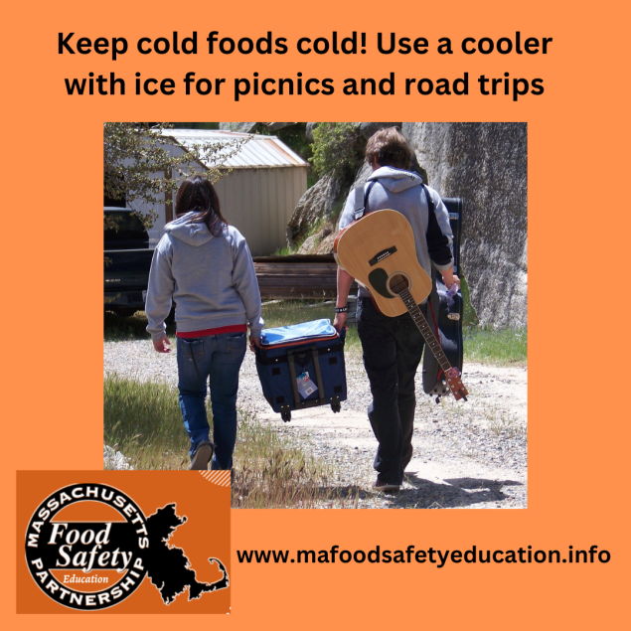

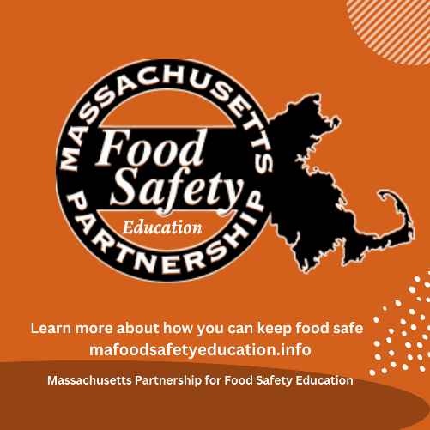

- June 7 is World Food Safety Day:
- Food safety has a direct impact on health.
- Unsafe food means people do not get the nutrients they need, and it makes 1 in 10 people sick every year. This often causes a vicious cycle of disease & malnutrition among the most vulnerable.
#WorldFoodSafetyDay
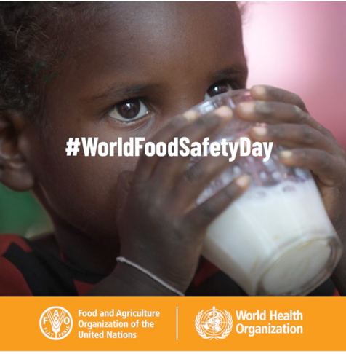
Download the GIF here:
WFSD23_precanned_social_media_posts_april_trello.docx (live.com)

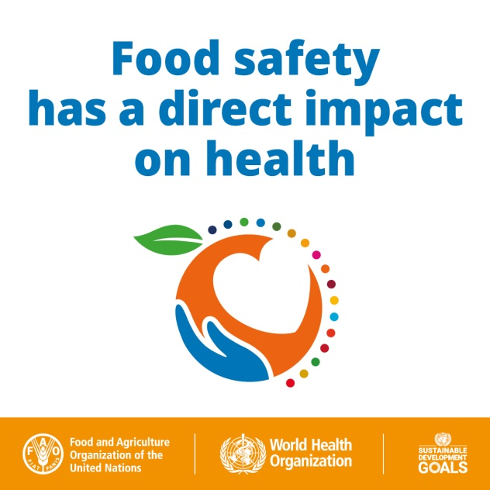
Image link: https://trello.com/1/cards/6050c2f3ef6a5102435e5c07/attachments/622217e6754ecb8df3d9a710/download/WFSDay2022_SMC_72dpi_04.jpeg

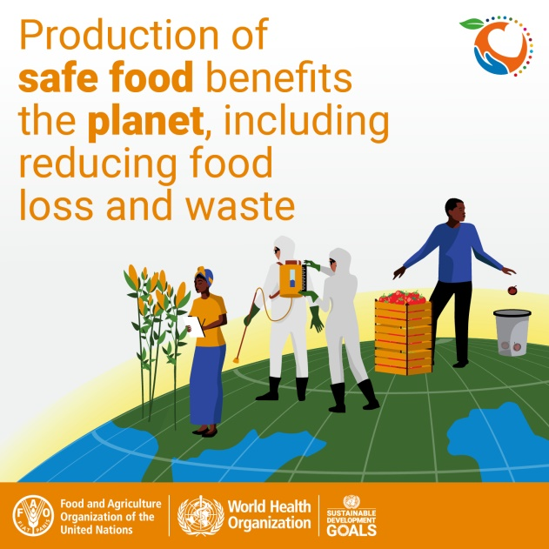
Image link: https://trello.com/1/cards/6050c2f3ef6a5102435e5c07/attachments/60e55b6e35cc0b8ae8c16595/download/WFSD21_SocialMediaCard_ENG_V3_Final2.jpeg

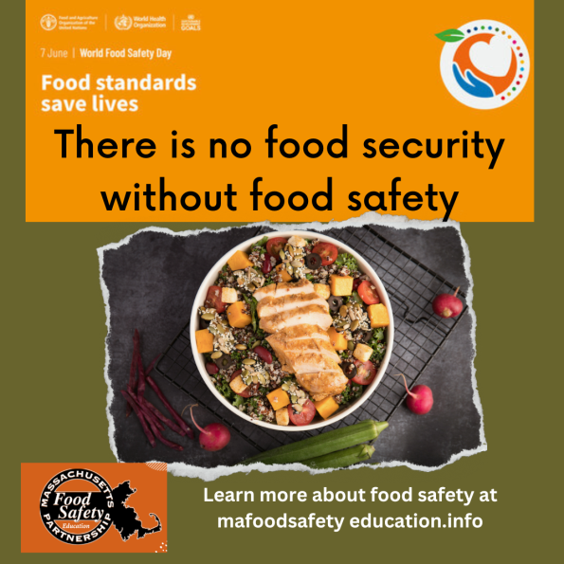

Please submit your evaluation by June 10 using this form: MPFSE Food Safety Summer Social Media Evaluation

